25th March 2022

Figma Design Link - <https://www.figma.com/file/VyUMlgZliIYyJVRn30nP6r/Paytriot?node-id=0%3A1>  
  
These are the figures from figma file that has to be animated  
  
**Homepage**

1. 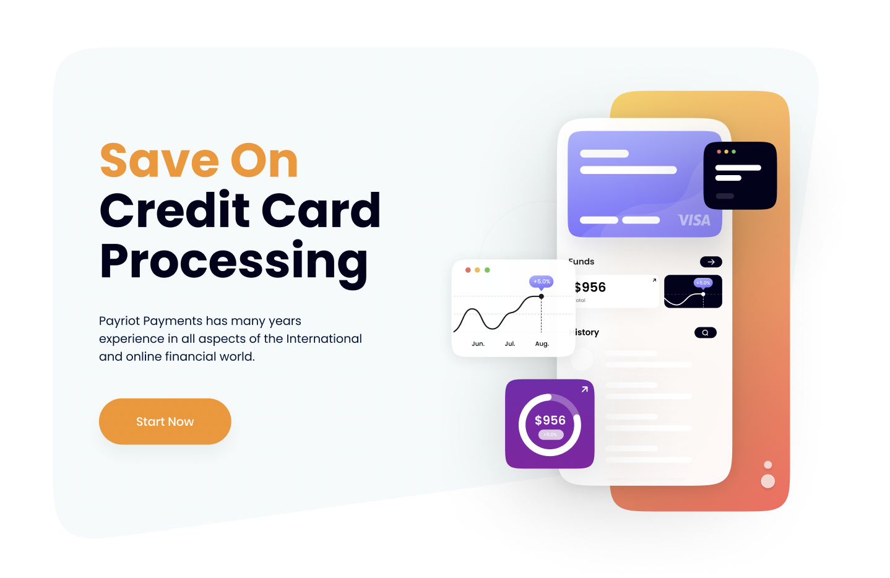
2. Changing color logos - we need both (greyed and colored) versions of the logo   
   
3. 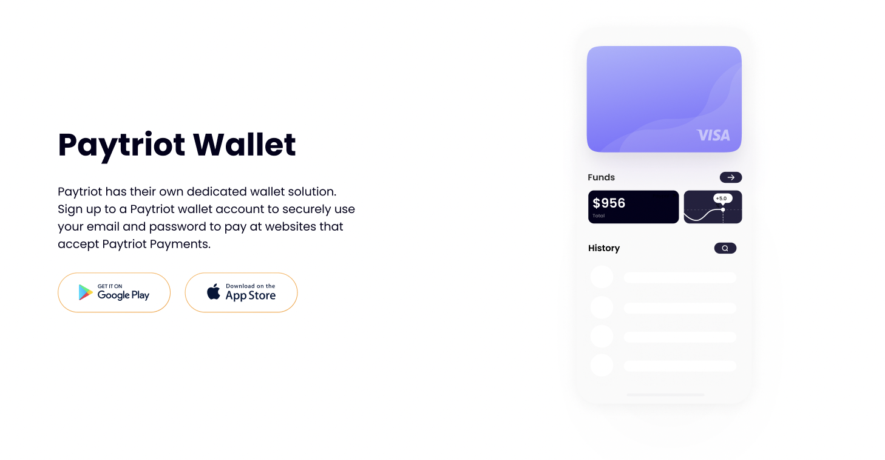
4. 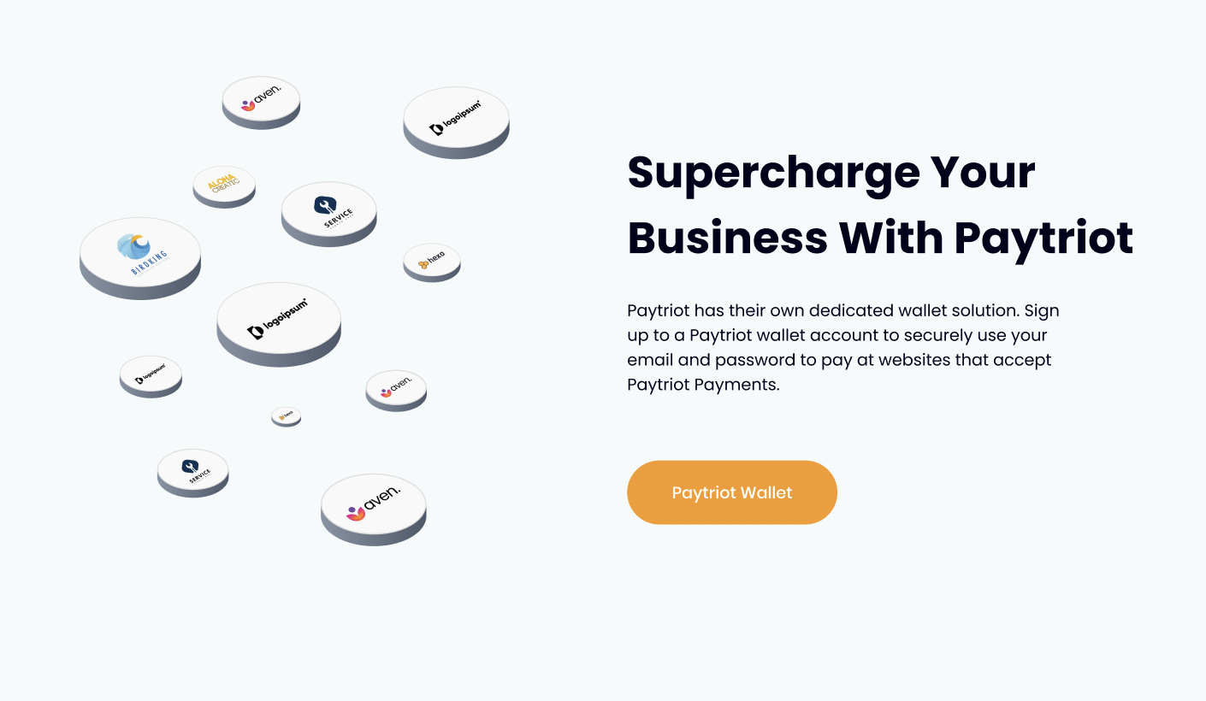
5. 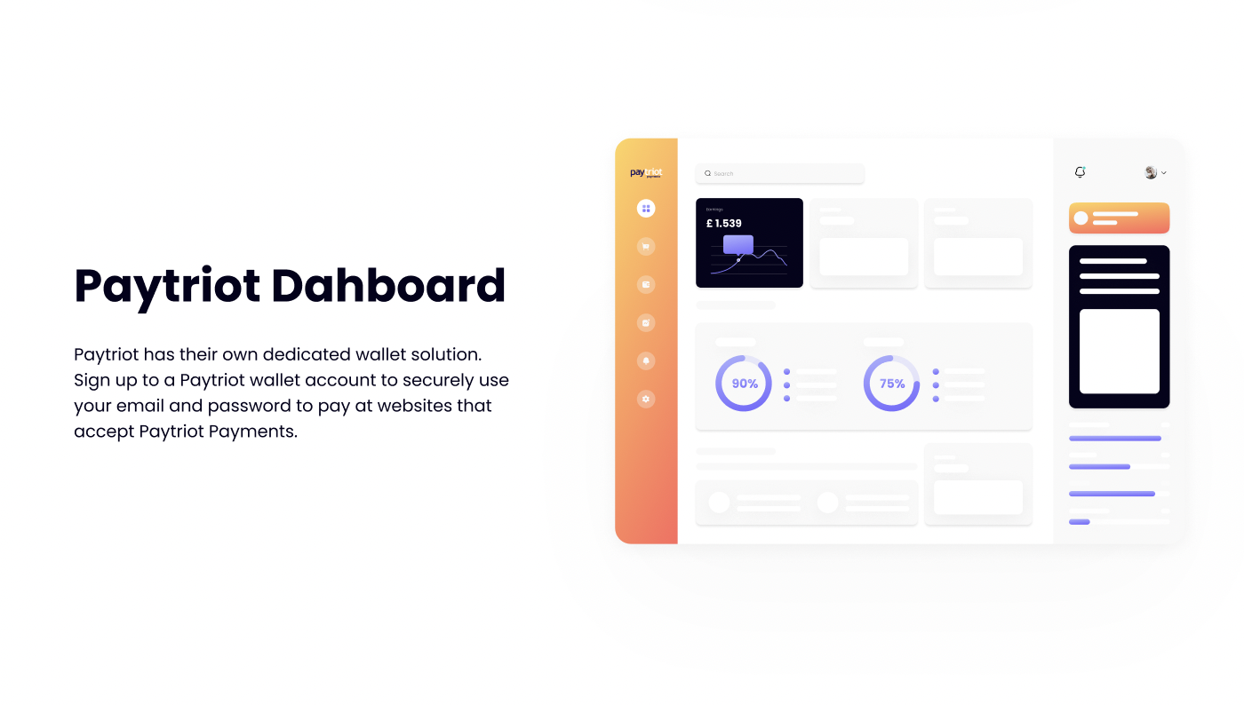
6. Three sections flipping over  
   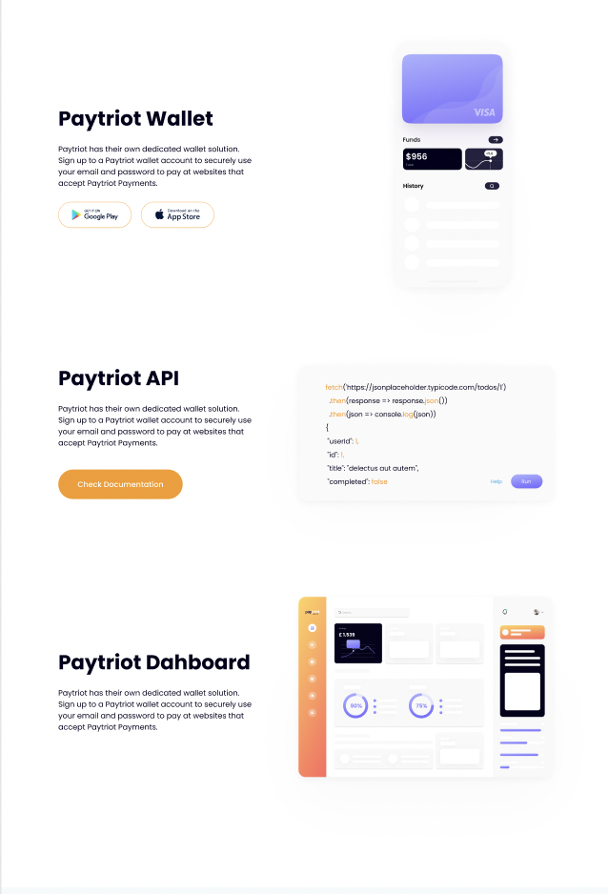
7. The flipping effect in the section  
   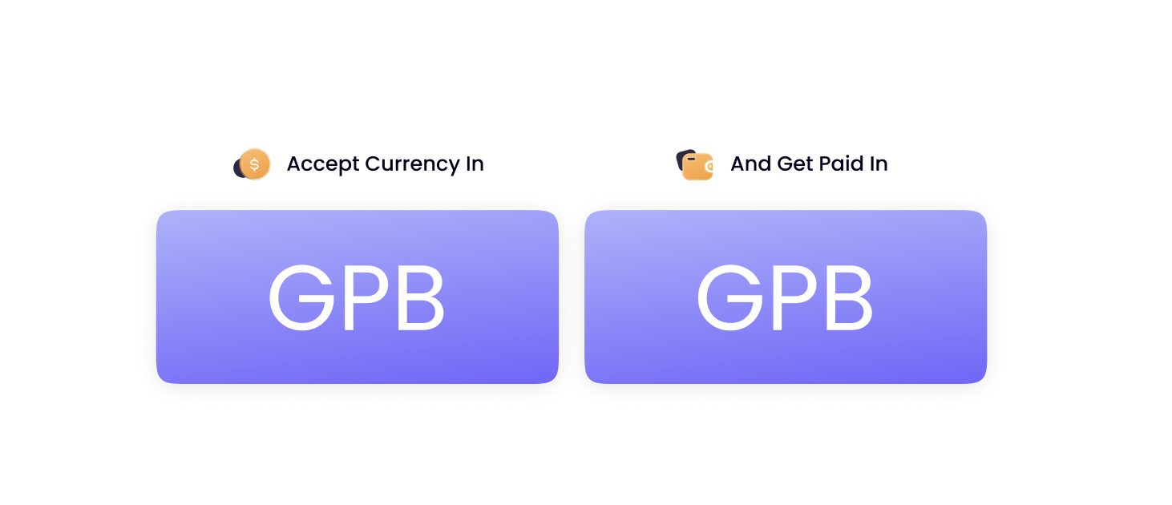

**About us**

We need to animate the timeline - like utrust.com’s about page

<https://utrust.com/about/>

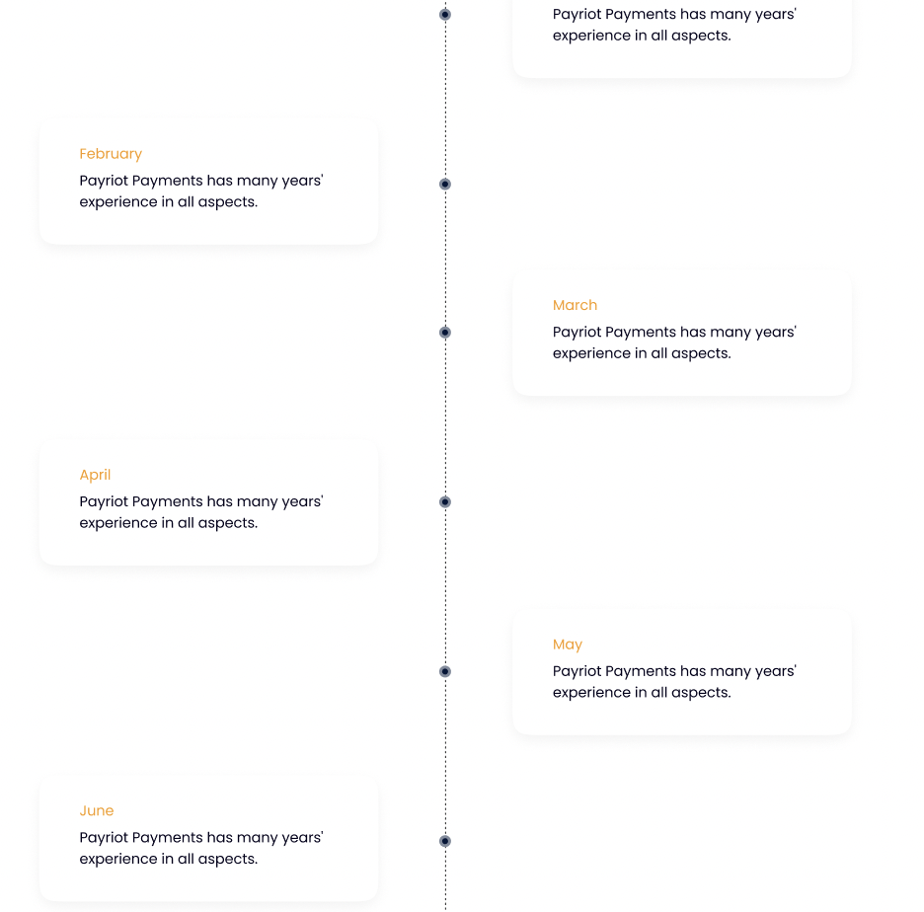  
  
  
  
  
  
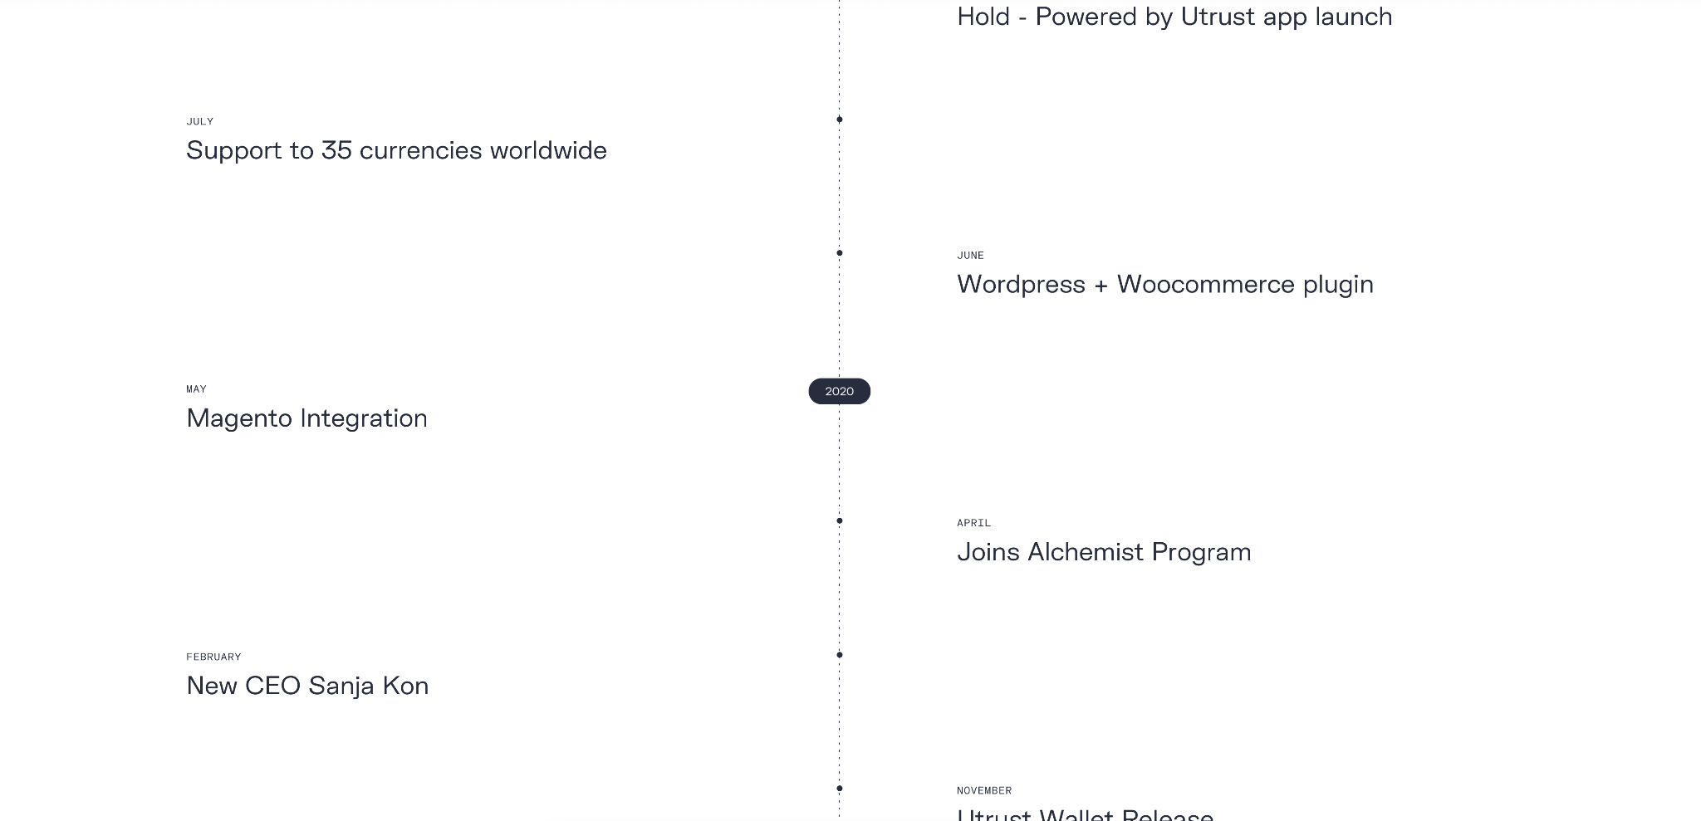

**Partners**  
  
General suggestion - We need to animate the partner page and it seems to be too static.

**Services**

1. 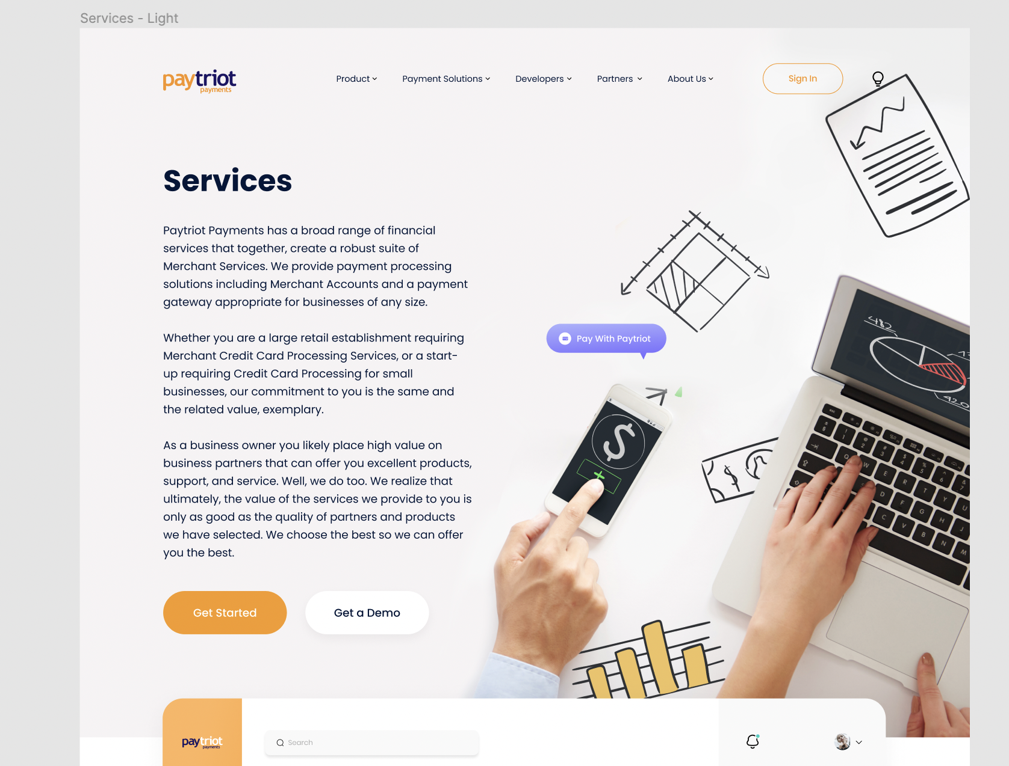
2. 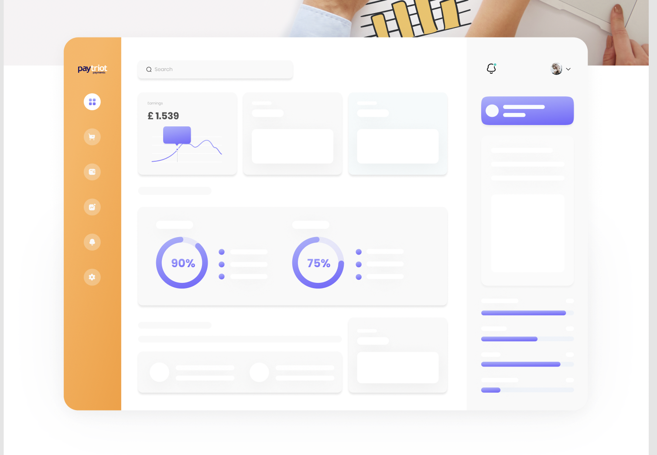
3. Animating the balls like utrust. Like it should be bouncing and interactive.   
   Also add the integration logos instead of text.   
   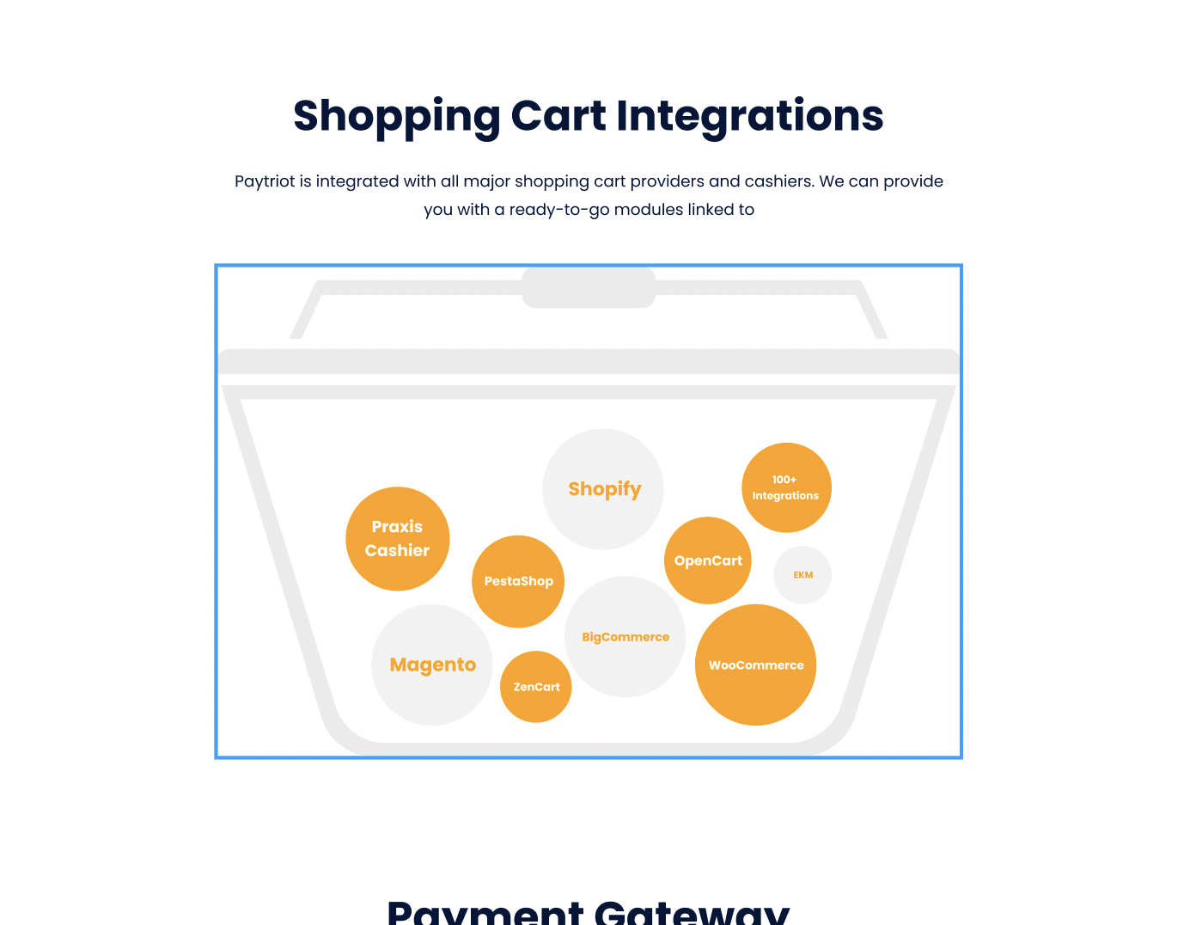
4. We need the below animation to be showing the full lifecycle of a payment from clients point of view -  
     
   Animations like typing credit card numbers -> mouse pointer clicking on pay button -> the order being placed successfully.  
   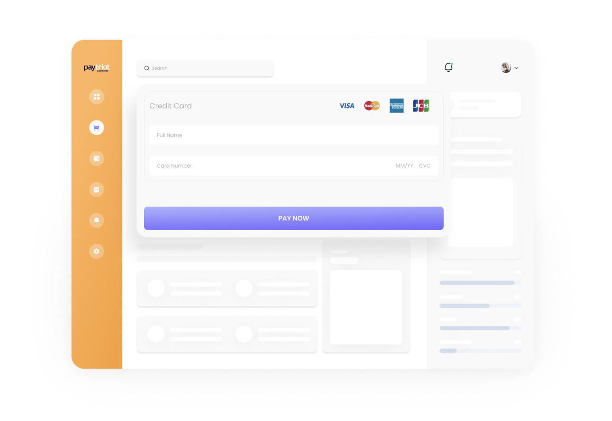

**Wallet**

1. 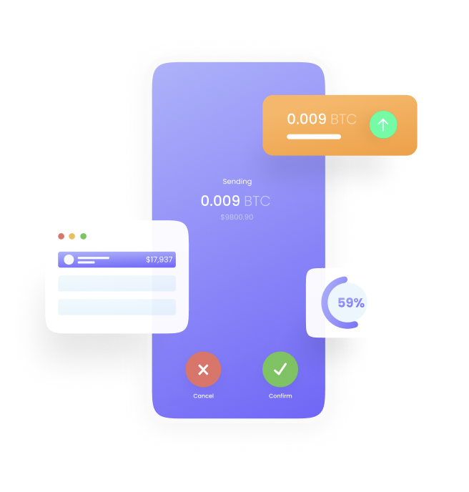
2. Animation - Sections should be expanding and closing as scrolling down the page.   
   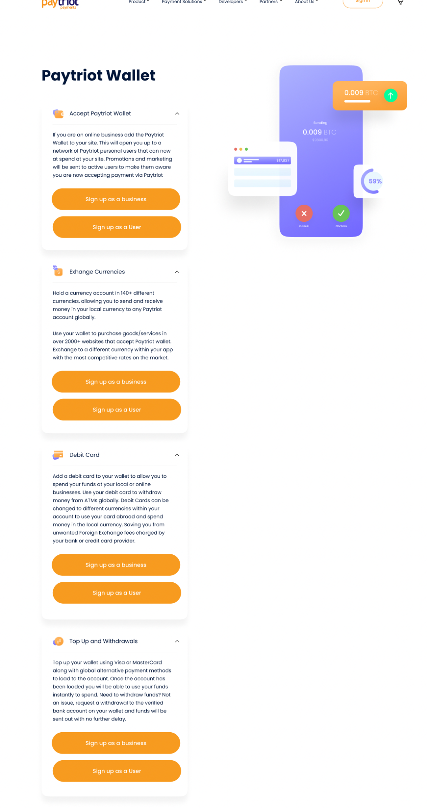

**Bank Account**

1. 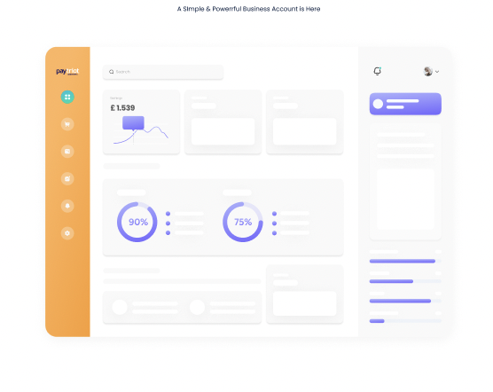
2. 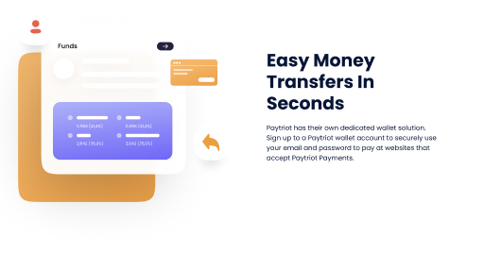
3. Animate these and please change text to “Currencies” instead of “Profit Value”.  
   